2. ReactJS-HOL
Creating React App : npx create-react-app studentapp

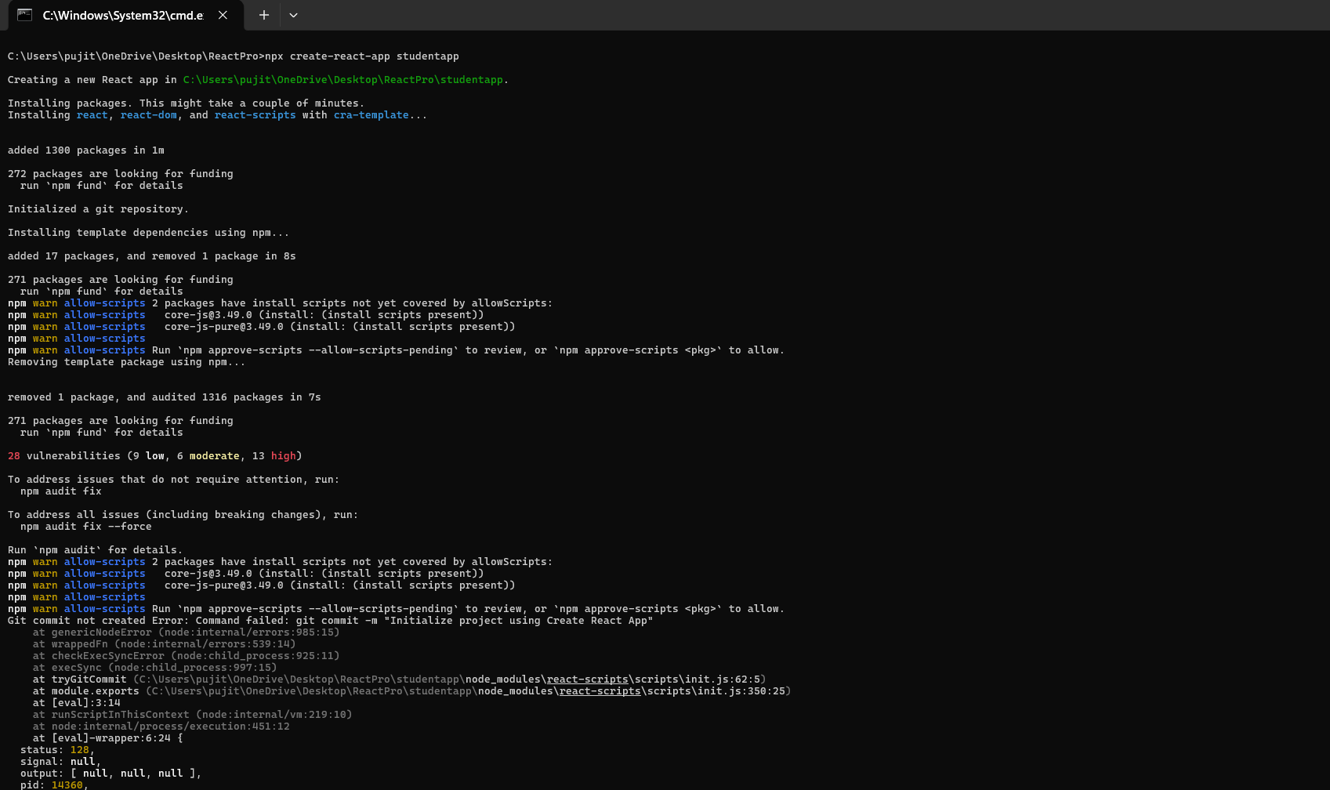
Home.js :
import React from 'react';
function Home() {
return (
<div style={{ padding: '10px', backgroundColor: '#f0f8ff', margin: '10px 0' }}>
<h2>Welcome to the Home page of Student Management Portal</h2>
</div>
);
}
export default Home;

About.js :
import React from 'react';
function About() {
return (
<div style={{ padding: '10px', backgroundColor: '#faebd7', margin: '10px 0' }}>
<h2>Welcome to the About page of the Student Management Portal</h2>
</div>
);
}
export default About;

Contact.js :
import React from 'react';
function Contact() {
return (
<div style={{ padding: '10px', backgroundColor: '#f5f5dc', margin: '10px 0' }}>
<h2>Welcome to the Contact page of the Student Management Portal</h2>
</div>
);
}
export default Contact;

App.js :
import React from 'react';
import Home from './Components/Home';
import About from './Components/About';
import Contact from './Components/Contact';
function App() {
return (
<div style={{ fontFamily: 'Arial, sans-serif', padding: '20px' }}>
<h1>Student Management Portal</h1>
<hr />
{/* Calling all three components here */}
<Home />
<About />
<Contact />
</div>
);
}
export default App;

Running on localhost 3000 :
